**APPLICATION TO USE THE PARLIAMENTARY GARDENS**

Please complete and return in a Word document format to [Gardens@parliament.tas.gov.au](mailto:Gardens@parliament.tas.gov.au).

If you have any questions regarding making an application please call (03) 6212 2366.

|  |  |  |  |  |
| --- | --- | --- | --- | --- |
| Applicant’s name and contact details: | Name:  Organisation:  Phone:  Email: | | | |
| Event details: |  | | | |
| Expected number attending: |  | | | |
| Date of event: | Start date: | Click or tap to enter a date. | Start time: |  |
| End date: | Click or tap to enter a date. | End time: |  |
| Bump in timeframe (time of setup and time of pack down): |  | | | |
| Area/s of Gardens requested (refer to attached picture of the Gardens area and specify quadrant/s and approximate space required): |  | | | |
| Detail on the use of any equipment or structures to be used:  (For example: marquees, sound amplifiers) |  | | | |
| Is the use of power required? |  | | | |
| Is vehicle access to the lawns required? |  | | | |
| Tasmania Police Approval (where applicable – see [www.police.tas.gov.au/services-online/permits-for-events](http://www.police.tas.gov.au/services-online/permits-for-events)): |  | | | |
| HCC Approval (where applicable – see www.hobartcity.com.au/Business/Place-of-assembly-licences): |  | | | |
| Any other relevant information: |  | | | |

**Contact person during the event:**

|  |  |  |
| --- | --- | --- |
| Contact name and phone number: |  |  |

|  |  |  |
| --- | --- | --- |
| **Impact that can be expected in the surrounding area:** | | |
| Noise | Interruptions due to requirement for vehicle access | Interruption – restricted access to lawns required |
| Interruption to pedestrian access | Nil impact | Other |

**Applicant’s Declaration**

In completing this application form, I have read, understood and accepted the attached *Guidelines for the Use of the Parliamentary Gardens* and the below ‘Standard Conditions of Authority to Proceed’ prior to submitting this form.

|  |  |
| --- | --- |
| Name: |  |
| Date: |  |

|  |
| --- |
| *Submission of this form does not guarantee the applicant the use of the Parliamentary Gardens. Applications are not to be considered granted until the Parliament has provided its approval in writing.*  *Parliament staff may contact the applicant to discuss and clarify details of any application. Depending on the size and nature of the proposed event additional information may be required from the applicant and any approval made subject to additional conditions.* |

|  |  |  |
| --- | --- | --- |
| **FOR PARLIAMENT USE ONLY** | | |
| **Authority to Proceed:** | | |
| Approved with standard conditions | Approved with special conditions | Not Approved |
| **Standard Conditions of Authority to Proceed:** | | |
| 1. Consent is provided to hold the event in the Parliamentary Gardens as detailed in this application and any annexures only. 2. The event is to be held in a way that is consistent with the attached *Guidelines for the Use of the Parliamentary Gardens*. 3. The Applicant is responsible for any damage to Parliament House or its gardens. 4. The Applicant is responsible for the removal of any signage and rubbish that may be left from their event. 5. The Parliament is to be contacted at [Security@parliament.tas.gov.au](mailto:Security@parliament.tas.gov.au) immediately in the event of any incident or issues arising from the event. | | |
| **Special Conditions of Authority to Proceed:** | | |
|  | | |

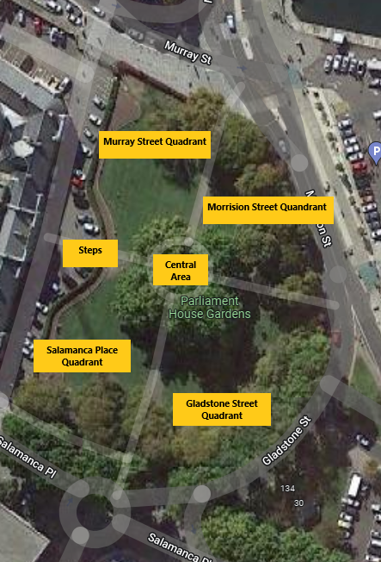

**GUIDELINES FOR THE USE OF THE PARLIAMENTARY GARDENS**

Applications for the use of the Parliamentary Gardens for an event are subject to the approval of the Presiding Officers of the Parliament of Tasmania. Such applications should be directed to the attention of the Secretary, Joint House Committee, Parliament House, Hobart.

At least fourteen days’ notice for an event is preferable.

In the event an application for approval of an event is granted, the use of the Parliamentary Gardens will be subject to the following conditions:

1. Any gathering of persons for the purpose of any event or protest is to be undertaken on the lawns of the Parliamentary Gardens.
2. No event or gatherings are to be undertaken in the Parliamentary Car Park located at the front of and at the northern end of Parliament House.
3. No person may remain on any steps or ramps which lead from such Parliamentary Car Park into Parliament House for the purposes of or in connection with any demonstration, protest, rally or event.
4. The centre steps, leading from the Parliamentary Car Park located at the front of Parliament House to the gardens, may be used as a speaking point for addresses to any event.
5. The hanging or attachment of banners or signage to trees and bushes in the Parliamentary Gardens is prohibited, as the trees are heritage listed. If the HCC arborist provides certification that the particular type of attachment will not damage the trees, approval may be given.
6. As there is an underground watering system, the insertion of any object into the lawns or garden beds, such as pegs, poles etc, is prohibited.
7. The use of confetti in the Parliamentary Gardens is prohibited.
8. The consumption of alcohol in the Parliamentary Gardens is prohibited.
9. Approvals are only for the use of the Parliamentary Gardens as a site – it is the responsibility of event organisers to contact the Hobart City Council to ascertain whether or not other approvals are necessary.
10. Contravention of the above conditions could result in refusal of future applications to hold an event.
11. Permits are for the use of the Parliamentary Gardens only.